**Assembly Sec C Lab 4 Fall 2017**

**CONDITIONAL JUMPS**

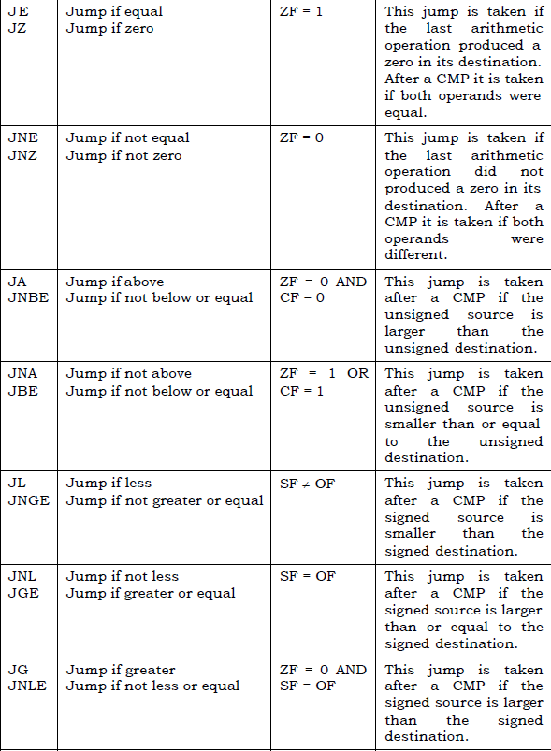

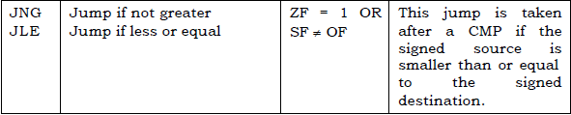

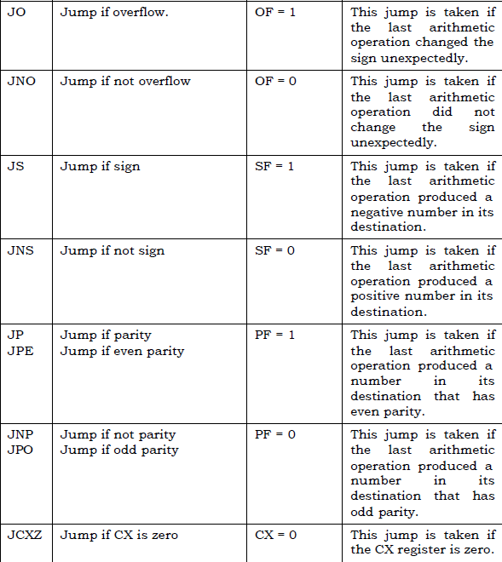

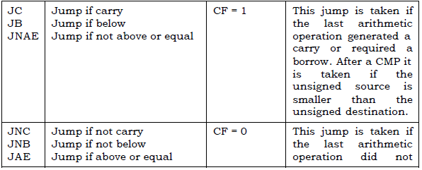

**Example**

|  |
| --- |
| ;; Find maximum in an unsigned array  [ORG 0x0100]    MOV BX,0  MOV CX,1  Replace:  MOV AX, [Array+BX] ;; AX has max ,  L1: cmp CX , [Size] ;;; Loop terminating condition {  Je Exit    Add BX ,2 ;; +2 in index because of word type array  Add CX,1 ;; counter to maintain size  CMP [Array+BX] , AX ;;; if condition if ( arr[BX] > max )  JA Replace ;; update maximum  JMP L1 ;;;;;; }  Exit:  MOV AX, 0x4C00 ;  INT 0x21 ; Terminate Program  Array: dw 1,2,5,0,8  Size: dw 5 |

**Problem 1:**

Convert the following C++ code into equivalent assembly code. (The logic in assembly code must mirror the logic in high level code)

Save larger number in Ax instead of output. Don’t consider output statements.

int n1 = 10 , n2 = 5 , n3 = 2;

if((n1 >= n2) && (n1 >= n3)) {

cout << "Largest number: " << n1;

}

else if ((n2 >= n1) && (n2 >= n3)) {

cout << "Largest number: " << n2;

}

else {

cout << "Largest number: " << n3;

}

**Problem 2:**

Write an assembly program which sets each byte of two non-overlapping but consecutive data segments to 0. (You may randomly take the first data segment starting point, but then for the 2nd data segment you have to calculate its starting point)

**Problem 3:**

You are given an array of positive numbers (db type array).Write a program that find an element (Key) in given array. If you find that element than replace that element with largest number of array. Otherwise append that element at the end of array.

Example: 3, 5,9,10,99,4,1,3,150,8

Key = 1

After My Program Array = 3,5,9,10,99,4,150,3,150,8

**Problem 4:**

Following is code to find intersection of two arrays

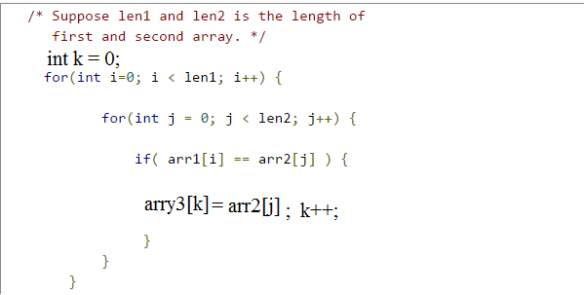

You have to write this code in assembly language

Store lengths of arrays in some register or memory, all arrays should db type. Every number in arrays should less than 255.

“This is the Book about which there is no doubt, a guidance for those conscious of Allah – **Who believe in the unseen, establish prayer, and spend out of what We have provided for them” (**AL-BAQARAH  2,3**) Think! Where we fall?????**